CITY OF CHILLIWACK

NOTICE OF PUBLIC INFORMATION MEETING
Tuesday, December 3, 2019 at 7:00 pm
Council Chambers
8550 Young Road, Chilliwack BC V2P 8A4
www.chilliwack.com

TAKE NOTICE that the Council of the City of Chilliwack will hold a Public Information Meeting, as noted above, on the following item:

- DEVELOPMENT VARIANCE PERMIT (DVP01102)

Location: 10151 Gillanders Road

Applicant: Gregory and Carly Volk

Purpose: To increase the maximum permitted building height from 6m to 6.3m for rural ancillary structures within the AL (Agriculture Lowland) Zone to facilitate the construction of a new 140m² workshop within the subject property, as shown on the map below.

Location Map

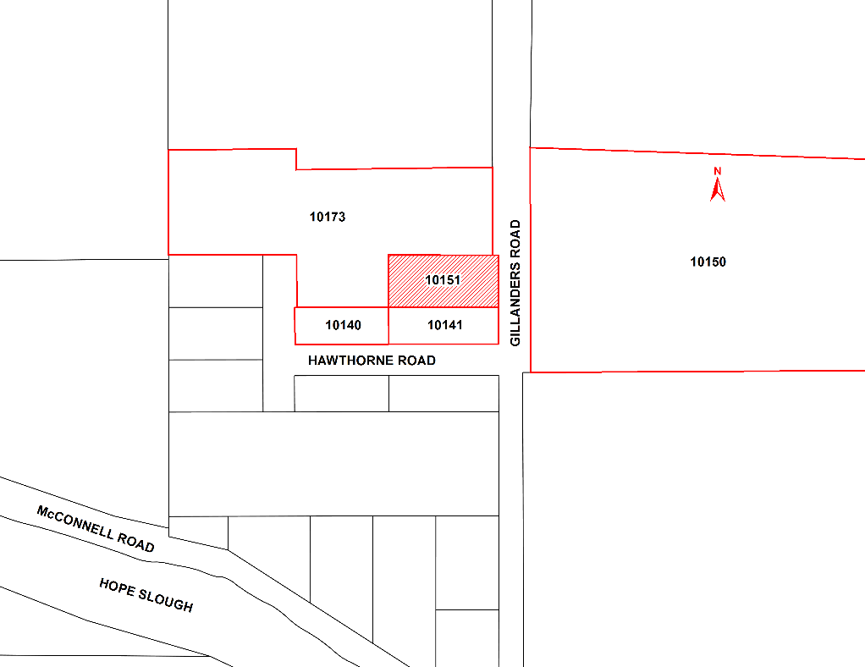

Property Owners and any tenants in occupation of lands directly affected by the permit and within 30 metres of the lands, as shown above, will have an opportunity to be heard at the Public Information Meeting, or if you are unable to attend, you may provide a written submission, including your full name and address, to the Corporate Services Department at 8550 Young Road, Chilliwack, BC, V2P 8A4 or by email to clerks@chilliwack.com no later than 4:00 pm on the date of the Public Information Meeting. All submissions will be recorded and form part of the official record of the Meeting.

This proposed Development Variance Permit may be inspected between the hours of 8:30 am and 4:30 pm, Monday through Friday, excluding holidays, from Wednesday, November 20, 2019 to Tuesday, December 3, 2019, both inclusive, in the Office of the Corporate Services Department at City Hall, 8550 Young Road, Chilliwack, BC. Please direct your enquiries to our Planning & Strategic Initiatives Department at 604-793-2906.

Please note that no further information or submissions can be considered by Council after the conclusion of the Public Information Meeting.

Jacqueline Morgan, CMC
Corporate Officer

